Correctly completing this fun Find A Word Destination and you will be entitled to a $50 gift voucher towards your Travel With A Difference holiday*

AUSTRALIA is AMAZING

B | R | U | N | Y | I | S | L | A | N | D | S
A | A | D | I | B | H | A | C | I | D | N | T
Y | W | A | N | Y | O | T | W | D | E | B | E
O | N | K | G | E | B | R | E | H | N | R | L
F | A | A | A | N | A | F | P | E | M | I | L
F | M | K | L | D | R | E | E | W | A | S | I
I | S | N | O | Y | T | G | R | O | R | B | V
R | S | S | O | S | I | U | T | H | K | A | S
E | O | W | T | H | W | L | H | D | Q | N | D
S | M | R | I | J | I | U | K | R | L | E | R
L | O | E | M | O | O | R | B | O | D | M | I
P | O | R | T | D | O | U | G | L | A | S | B
H | O | U | N | Y | A | B | N | O | R | Y | B

Find these words hidden horizontally, vertically and diagonally, forwards and backwards.

NSW | Port Stephens | Sydney | Byron Bay | Lorde Howe
TAS | Bay of Fires | Huon | Hobart | Bruny Island
WA | Denmark | Broome | Perth | Ningaloo
NT | Darwin | Uluru | Kakadu | Tiwi
QLD | Brisbane | Birdsville | Mossman | Port Douglas

*Gift voucher can be redeemed for a Holiday within Australia that includes return flights and five nights accommodation twin/double share. Valid for bookings made before 20 December 2020 with travel to be completed by 20 December 2021. Not valid with any other promotion or offer. © Travel With A Difference 2020.

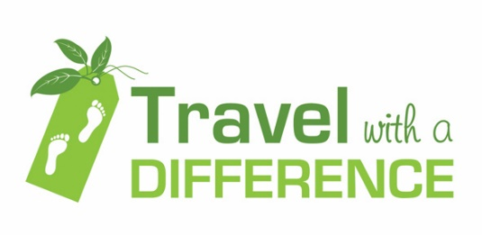

www.travelwithadifference.com.au

